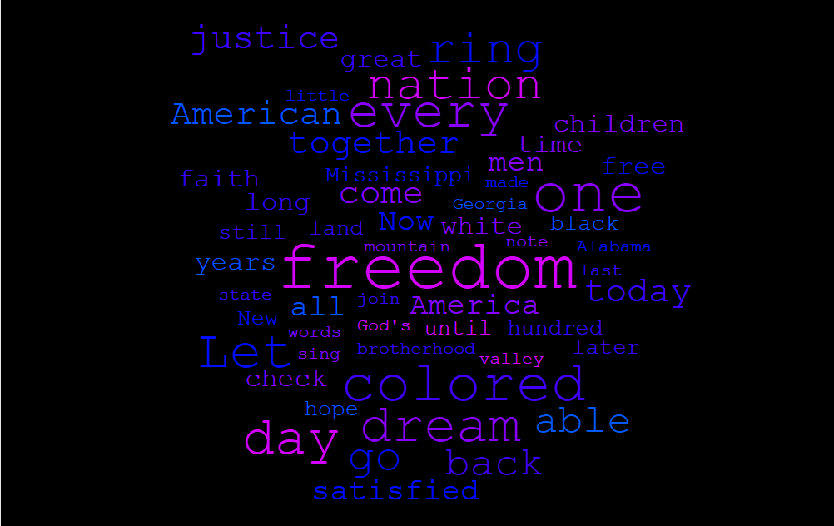

Total number of words:54

Minimum frequency: 3

This text data was taken from Martin Luther King’s “I have a dream speech”. It is no surprise that the most common word used is freedom, given what the civil rights movement was about. Black Americans were protesting for equality. Segregation laws, voter suppression, and targeted police violence were all things that either restricted civil liberties, or violated the rights of Black Americans.

Nation, every, dream and colored appear to be the most significant words in terms of the consistency at which they appear in the text.